**EXP NO 25. Database as a Service (DaaS) create and configure a new VM Image in any Public Cloud Service Provider using Azure.**

**AIM:**

To create a Database as a Service (DaaS) and configure a new VM Image in any Public Cloud Service Provider using Azure.

Procedure:

Procedure:

1. Log in to Azure Portal – [https://portal.azure.com](https://portal.azure.com/)
2. Create a Resource Group → Name: DaaS-RG → Click Create
3. Go to Create a Resource → Virtual Machine
   * Resource Group: DaaS-RG
   * VM Name: daasvm
   * Image: Windows Server or Ubuntu
   * Size: 1 vCPU, 1GB RAM
   * Set username and password → Create
4. Connect to the VM using RDP (Windows) or SSH (Linux).
5. Install a Database Server (SQL Server or MySQL) inside the VM.
6. Go to VM → Capture → Create Image → Name: daasvmimage.
7. Enter Version number: 1.0.0 → Click Review + Create → Create. Design:

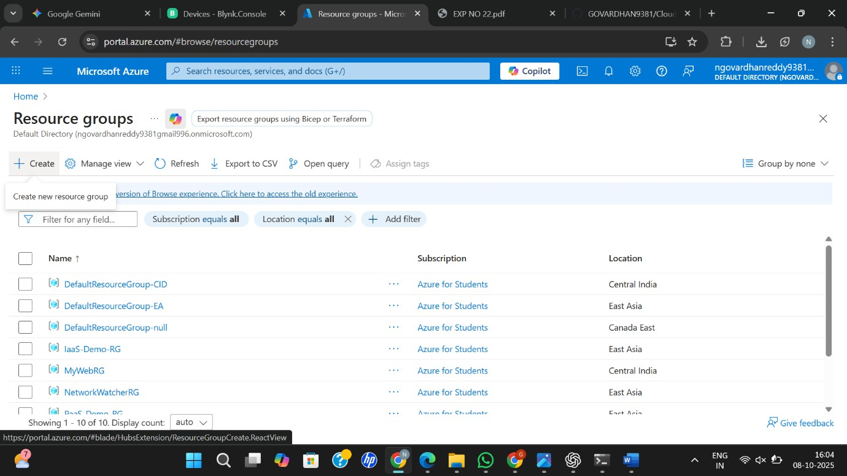

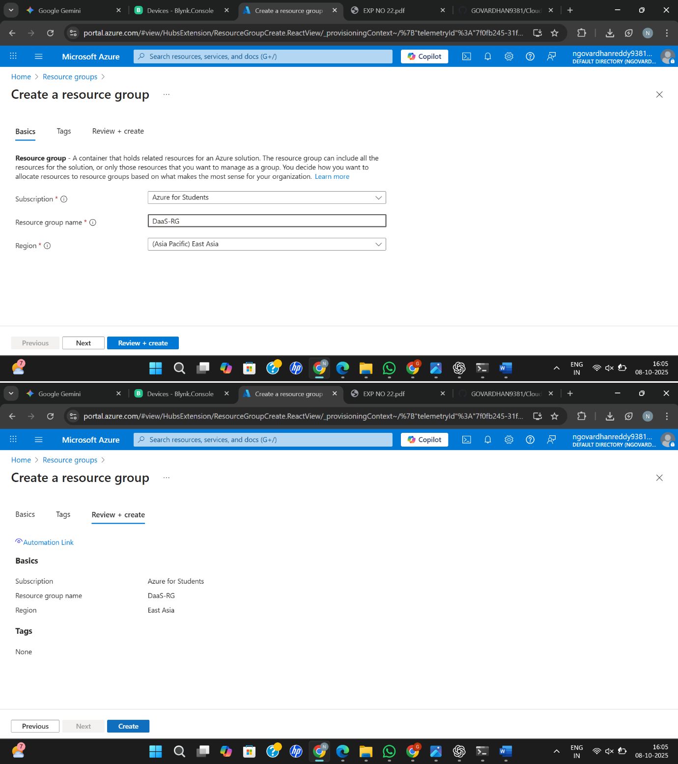

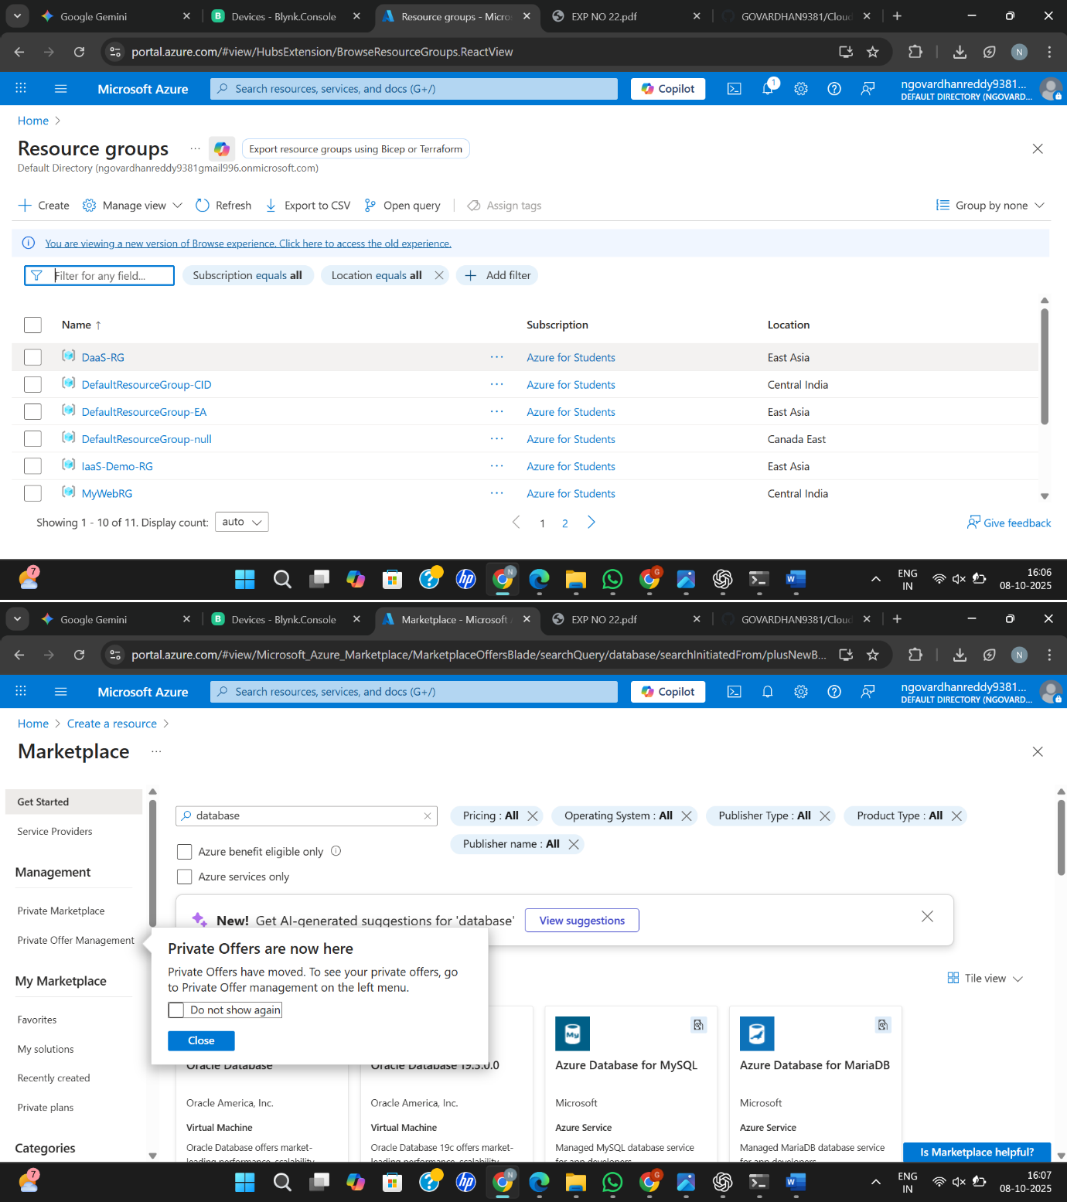

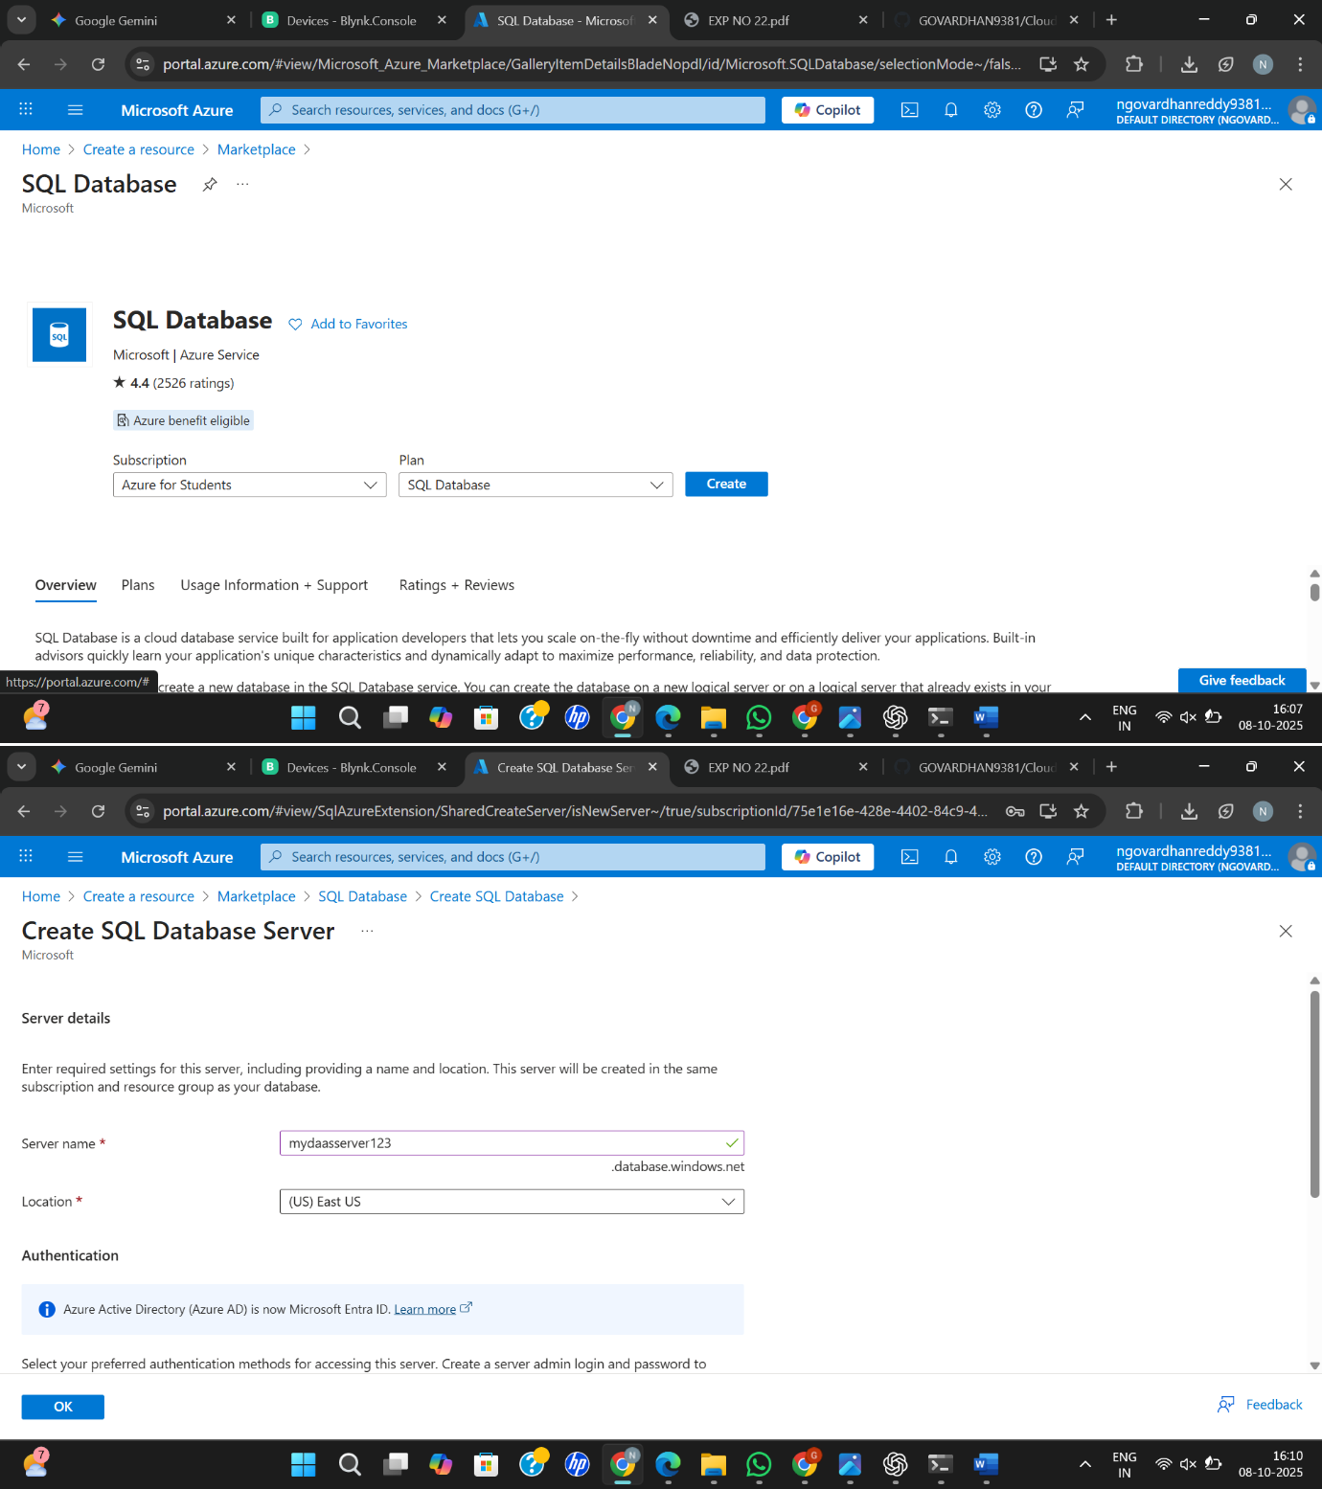

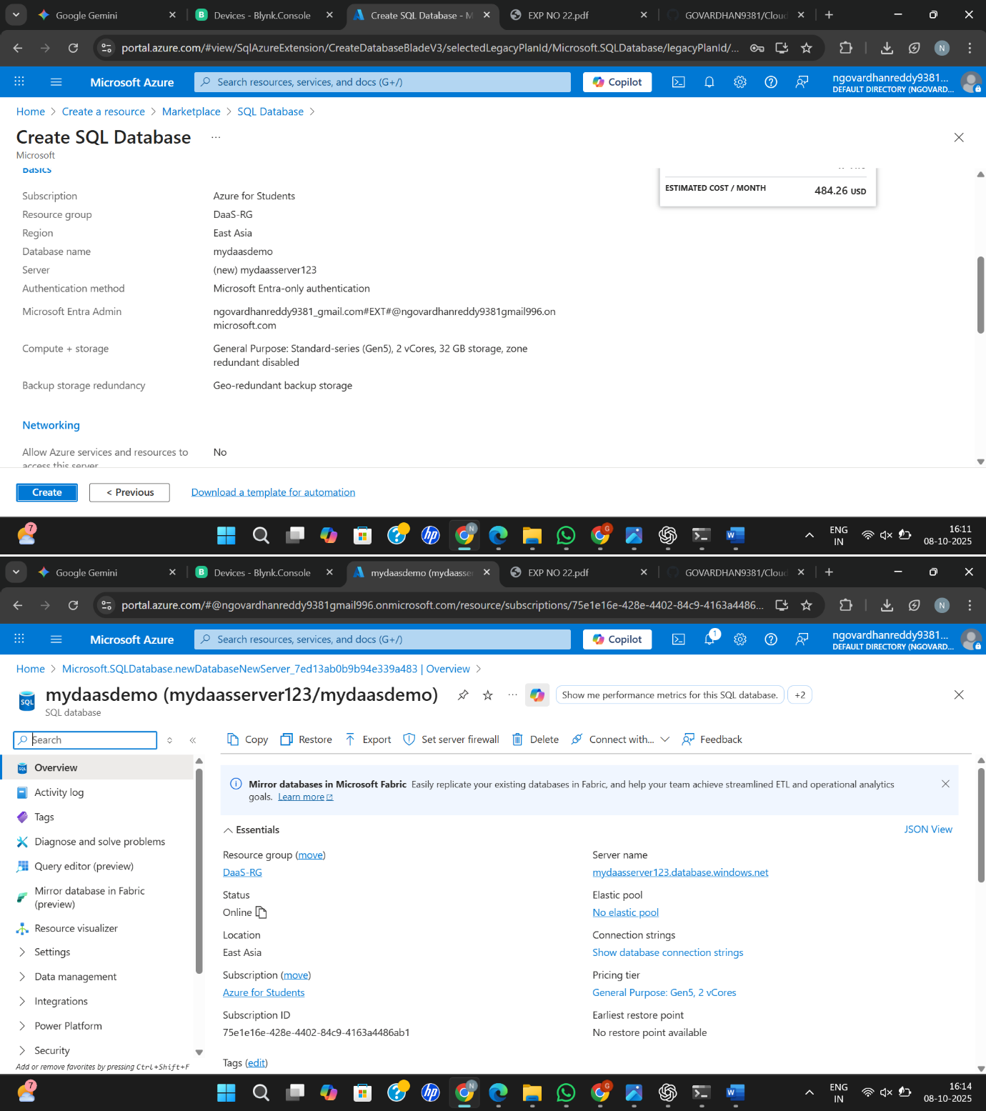

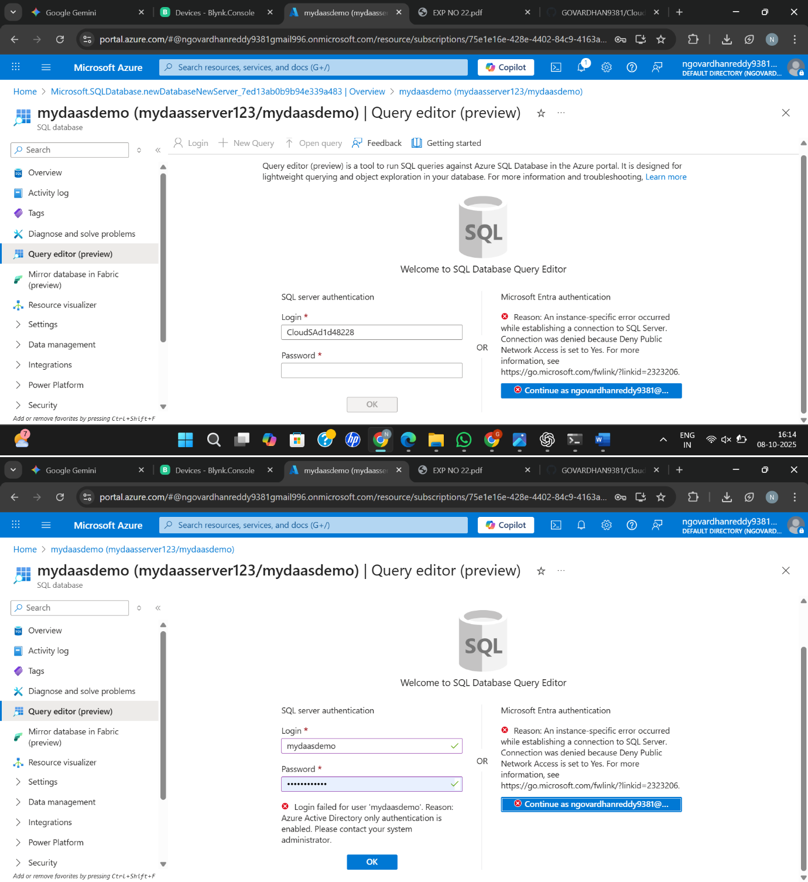

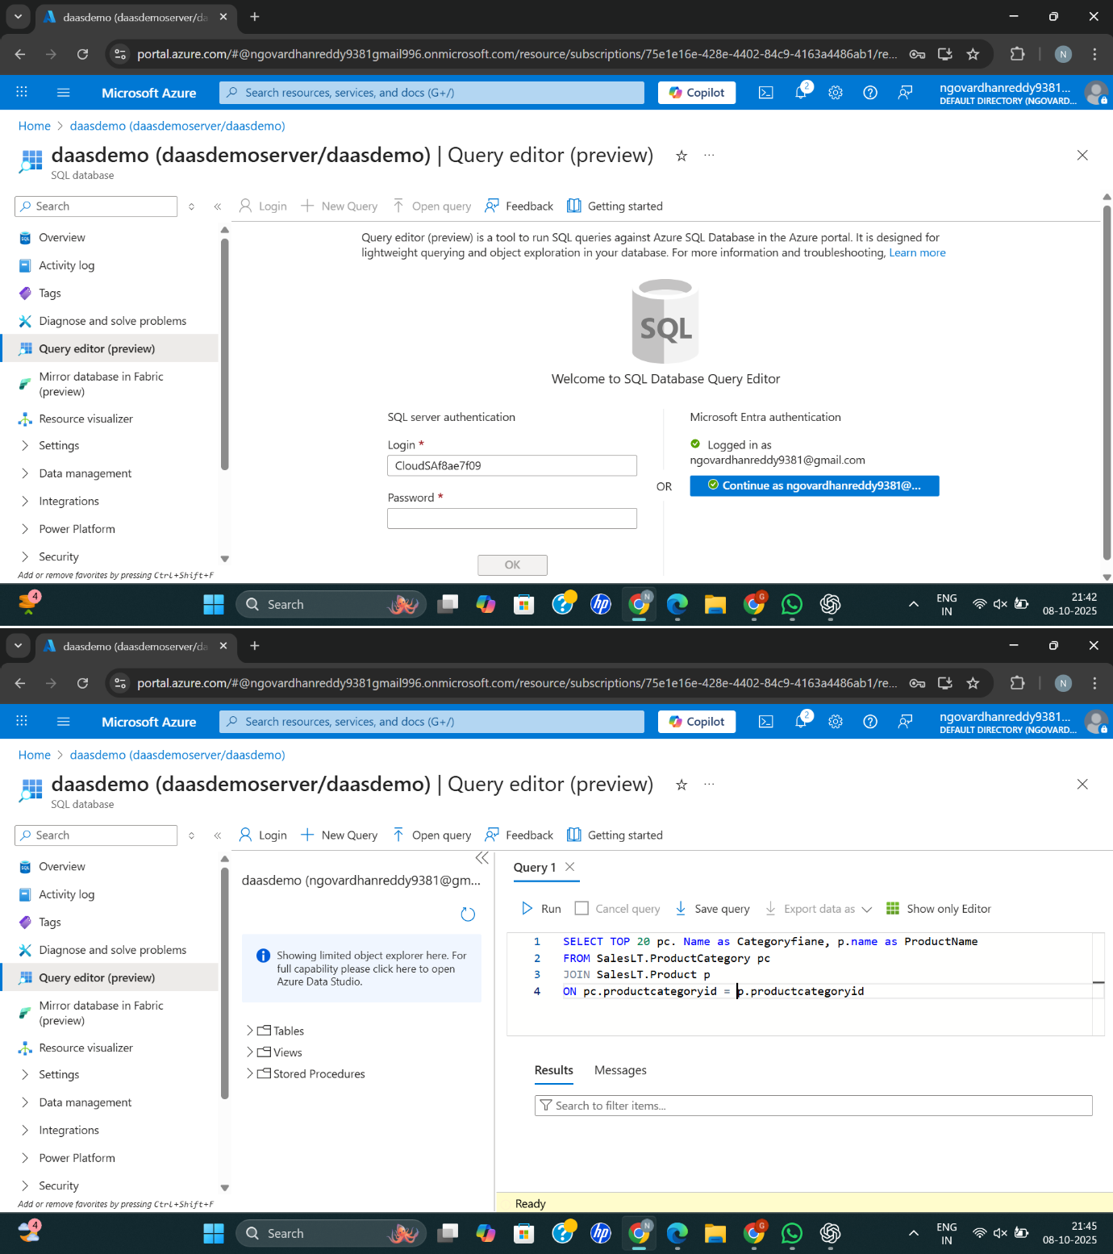

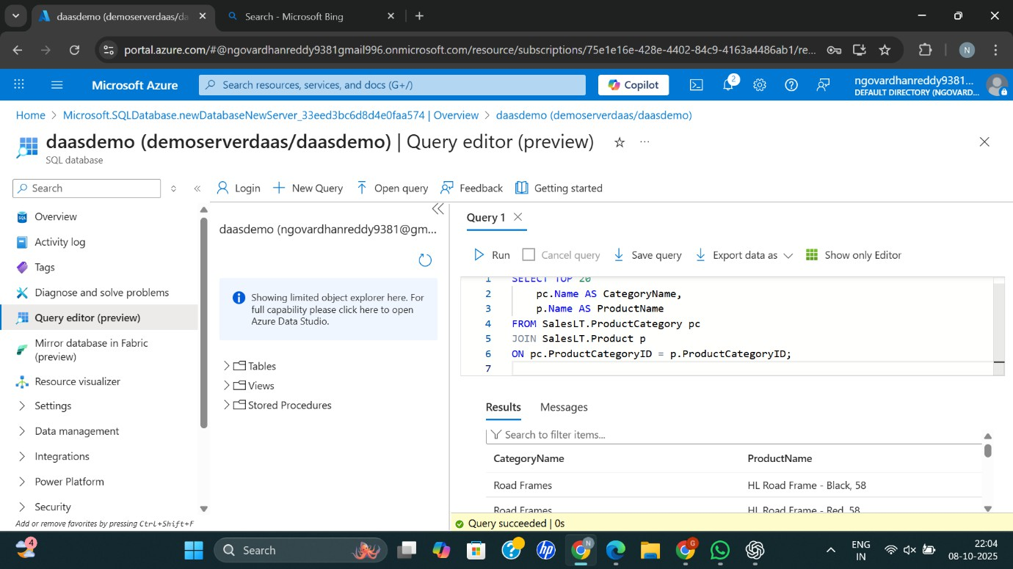

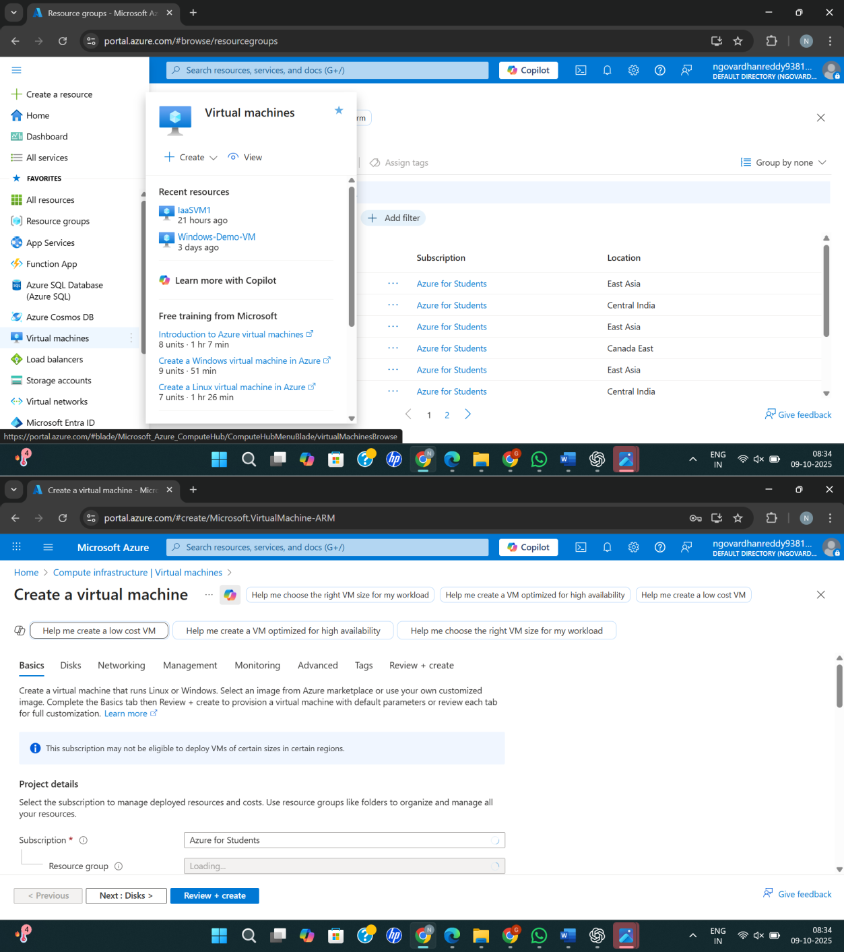

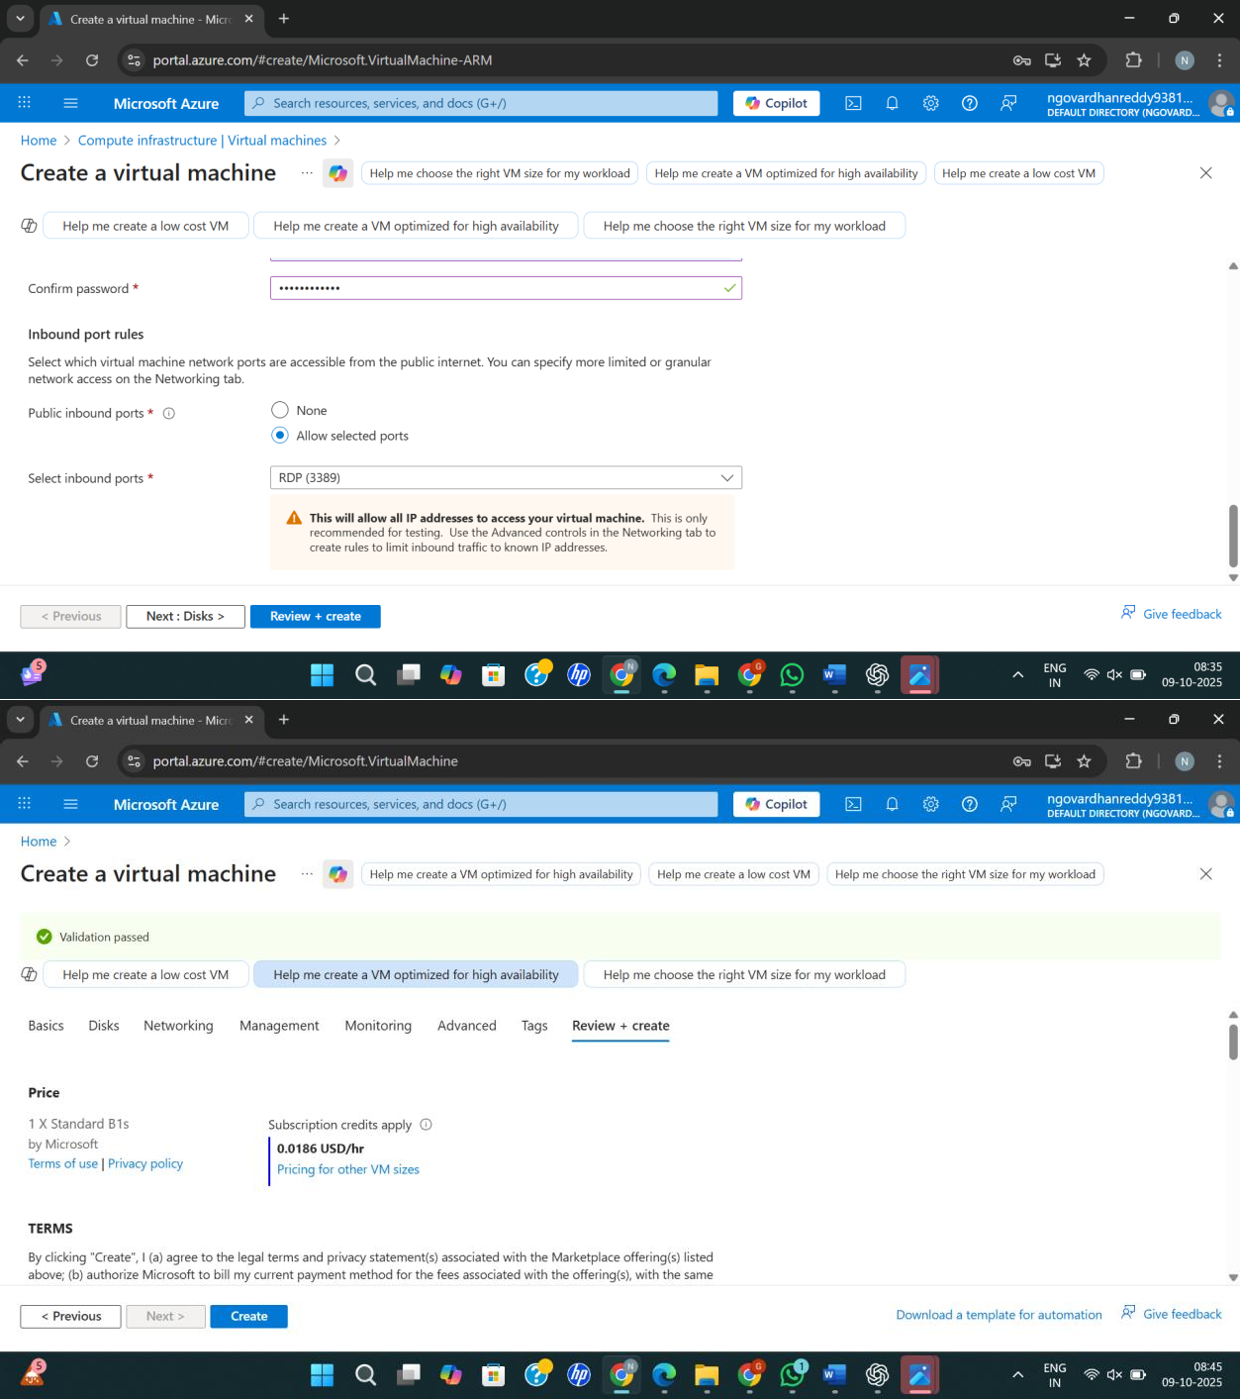

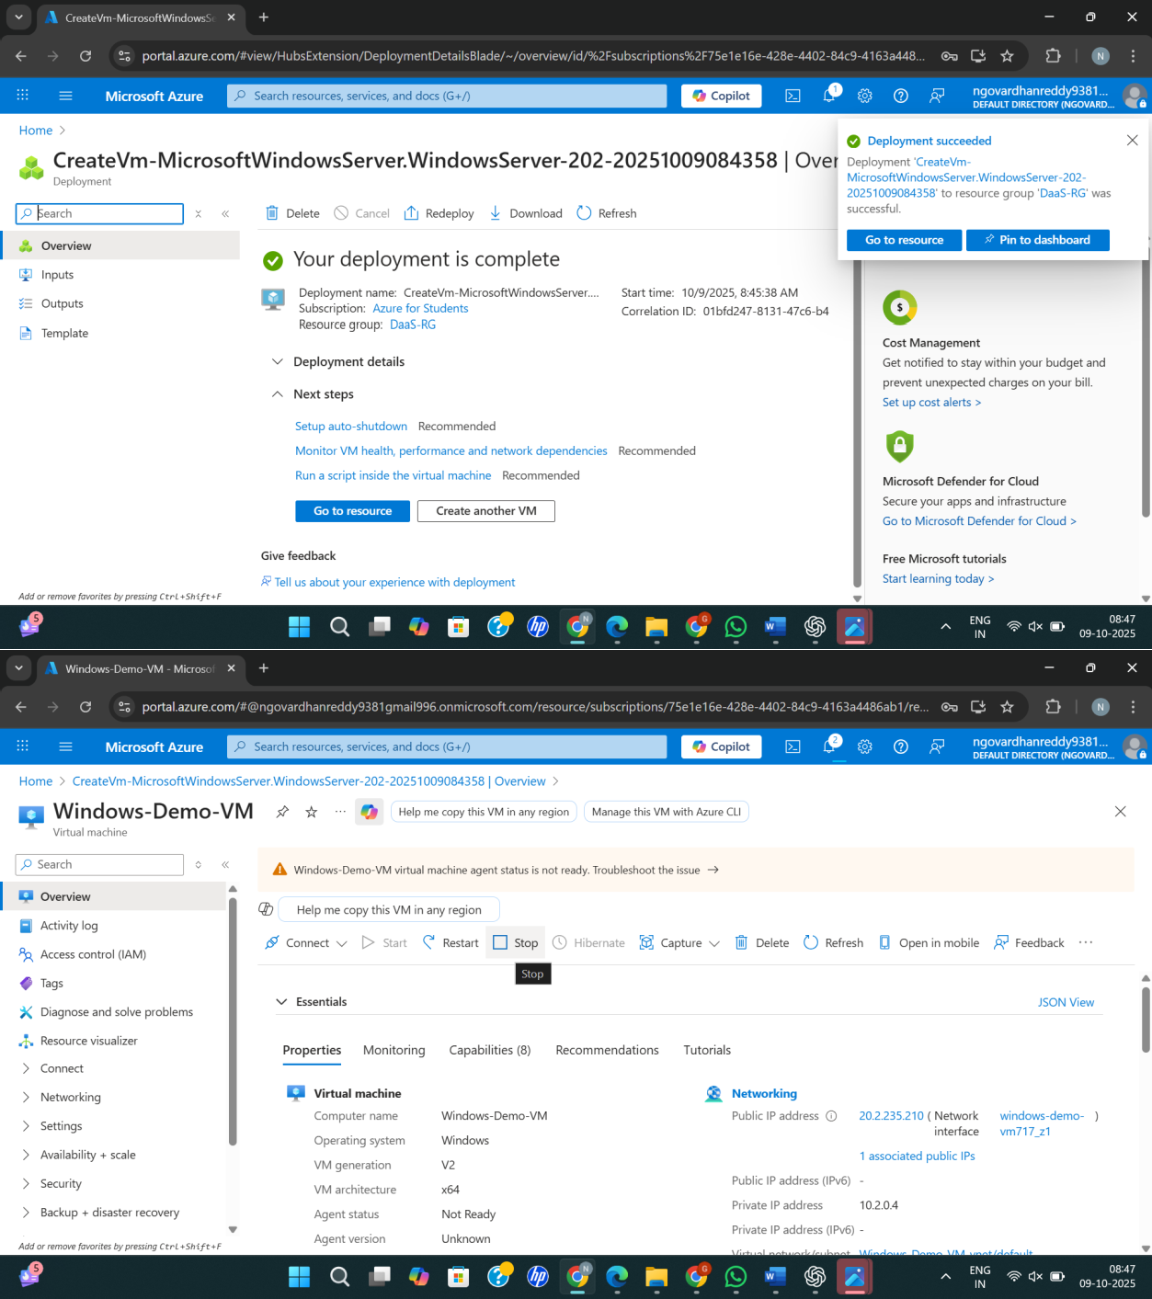

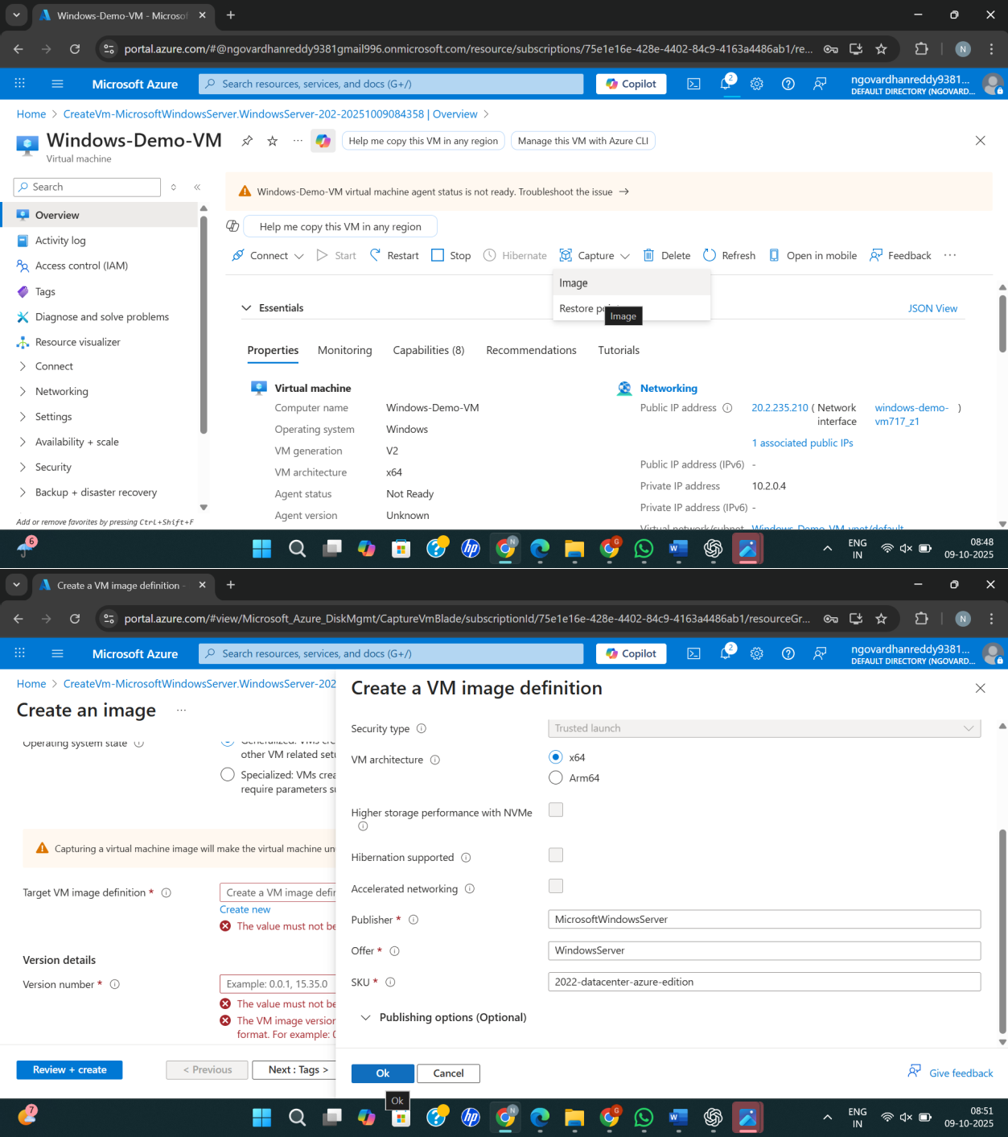

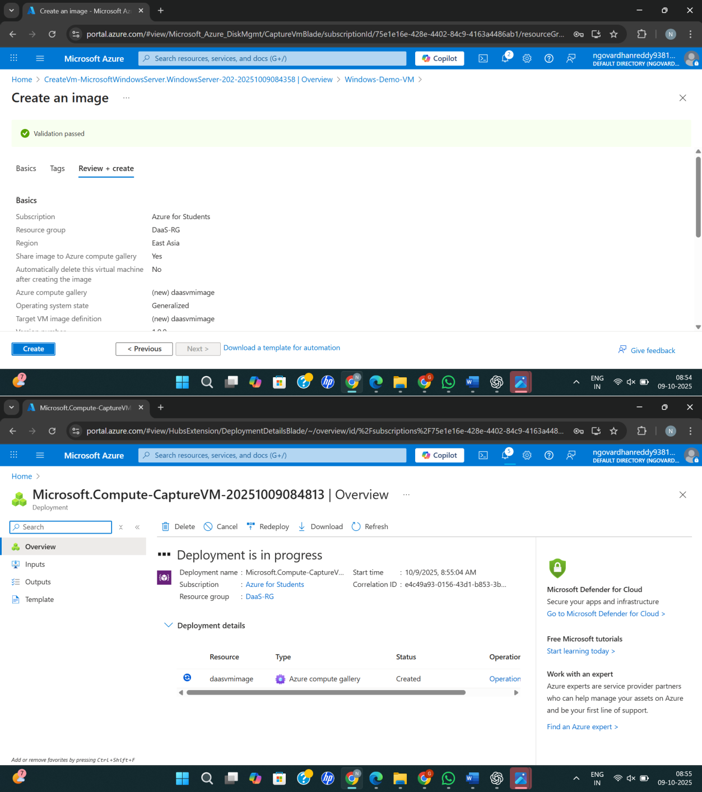

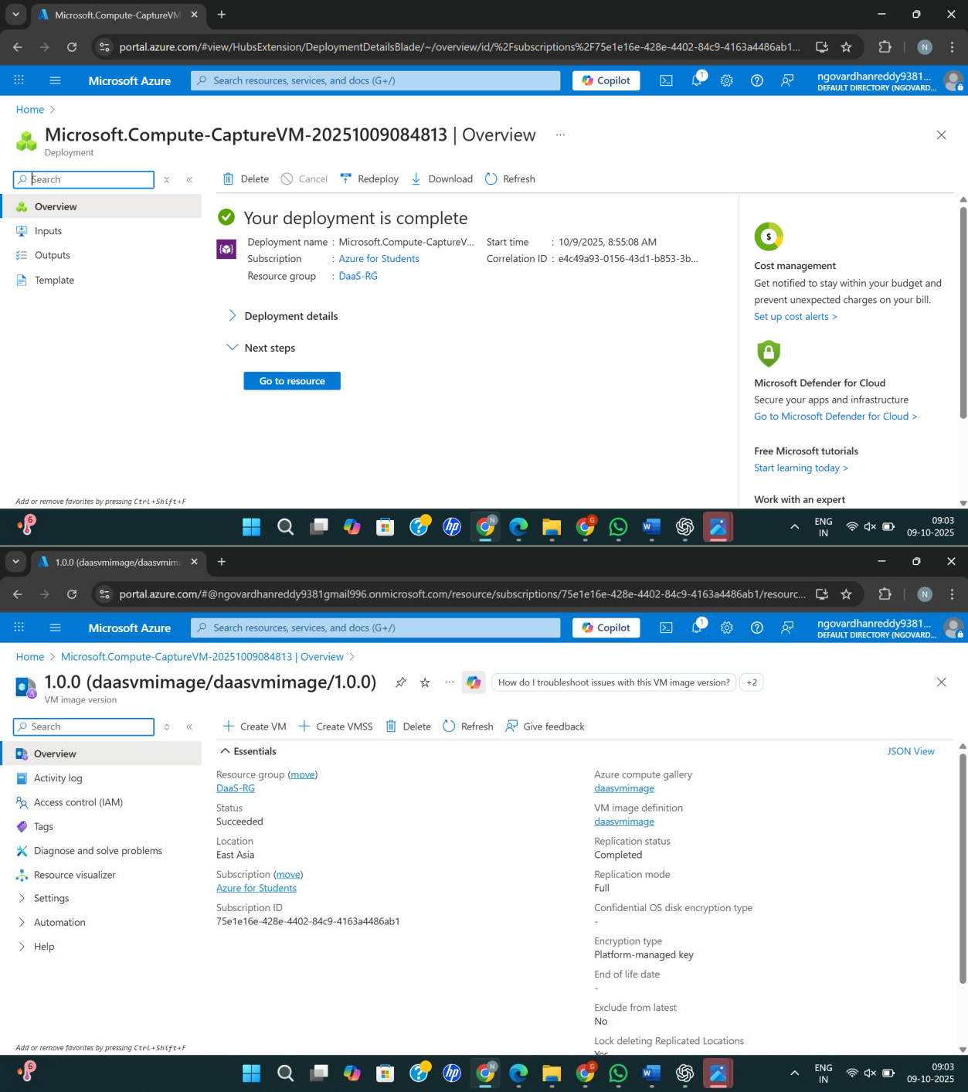

Result:

Successfully created and configured a VM Image to demonstrate Database as a Service (DaaS) in Azure.